Final Project Report

CarWash



Project Supervisor
Syed Aun Ali Bukhari

Submitted By

F24PROJECT72E6E

Adeel Ahmed BC210406443

Software Projects & Research Section,
Department of Computer Sciences,
Virtual University of Pakistan


CERTIFICATE

This is to certify that Adeel Ahmed (BC210406443) has worked on and completed their Software Project at Software & Research Projects Section, Department of Computer Sciences, Virtual University of Pakistan in partial fulfillment of the requirement for the degree of BS in Information Technology under my guidance and supervision.

In our opinion, it is satisfactory and up to the mark and therefore fulfills the requirements of BS in Information Technology.

Supervisor / Internal Examiner

Syed Aun Ali Bukhari
Supervisor,
Software Projects & Research Section,
Department of Computer Sciences
Virtual University of Pakistan

___________________
(Signature)

External Examiner/Subject Specialist
<<External Supervisor Name>>

___________________
(Signature)

Accepted By:

_____________
(For office use)

EXORDIUM

In the name of Allah, the Compassionate, the Merciful.

Praise be to Allah, Lord of Creation,
The Compassionate, the Merciful,
King of Judgment-day!

You alone we worship, and to You alone we pray for help,
Guide us to the straight path

The path of those who You have favored,

Not of those who have incurred Your wrath,
Nor of those who have gone astray.

DEDICATION

I dedicate my project work to my family and friends. A special feeling of gratitude to my loving parents, whose words of encouragement and push for tenacity ring in my ears.
I also dedicate this project to my many friends and family who have supported me throughout the process. I shall always appreciate all they have done, especially my supervisor, to help me develop my skills, for the many hours of proofreading and coordinate management sciences for helping me master the leader of dots.
I dedicate this work and give special thanks to my loving supervisor Mr. Syed Aun Ali Bukhari and all my teachers who teach and help me a lot to learn.

ACKNOWLEDGEMENT

First of all, I am thankful to ALLAH Almighty, who awarded me good health and capabilities to accomplish the task successfully given to me. Without his help, I could not perform this task. I am very thankful to my parents, who support me.
I am also thankful to the Virtual University of Pakistan and my honorable supervisor Syed Aun Ali Bukhari who is always there to support and help me, whose contribution and encouragement pushed me to make the project in time. I am thankful to them for their continuous constructive criticism and invaluable suggestions, which benefited me greatly while developing this project. I made this project not only for marks but also to increase my knowledge.
I wish to say thanks to my project mate who helped me sharing their opinion with a great mind and to all staff members who were directly or indirectly instrumental in enabling me to stay committed. Thanks to all of them.
PREFACE
This document presents the development of our CarWash Management System, designed to make the car wash process easier for both the company and its customers. Our system helps admins manage users, services, bookings, inventory, and payments efficiently. It also allows customers to easily view services, book appointments, make payments, and give feedback.

We built this project to solve common problems in car wash businesses, like managing customer appointments, keeping track of supplies, and improving customer service. With this system, we aim to save time, reduce manual work, and provide a better experience for everyone involved.

This project is the result of careful planning, teamwork, and continuous learning. We hope it will bring real benefits to car wash businesses and their customers by making operations smoother and more organized.

Table of Contents

CHAPTER 1
Gathering and Analyzing Info
1.1 INTRODUCTION 10
1.2 PURPOSE 10
1.3 SCOPE 10
1.4 DEFINITIONS, ACRONYMS AND ABBREVIATION 11
1.5 PROJECT REQUIREMENTS 11
1.5.1 Functional Requirements 11
1.5.2 Non-Functional Requirements 13
1.6 USECASES AND USAGE SCENARIOS 15
1.6.1 Use Case Diagram 15
1.6.2 Usage Scenario 16
1.7 DEVELOPMENT METHODOLOGY 27
1.7.1 VU Methodology 27
1.7.2 Reason for Choosing VU Methodology 32
1.7.3 Working Plan 33
1.7.4 Project Schedule 33
CHAPTER 2
Designing the Project
2.1 INTRODUCTION 36
2.2 PURPOSE 36
2.3 SCOPE 36
2.4 DEFINITIONS, ACRONYMS AND ABBREVIATION 37
2.5 ER DIAGRAM 37
2.6 ARCHITECTURE DIAGRAM 39
2.7 DYNAMIC MODEL (SEQUENCE DIAGRAM) 40
2.7.1 Login 40
2.7.2 Register 41
2.7.3 Manage User 42
2.7.4 Manage Services Sequence 43
2.7.5 Manage Booking 44
2.7.6 Generate Report 45
2.7.7 View Service 46
2.7.8 Send Booking 47
2.7.9 Manage Profile Sequence 48
2.7.10 Search Service 49
2.7.11 View Notification 49
2.7.12 Give Feedback 50
2.7.13 Logout 51
2.8 LOGICAL MODEL (CLASS DIAGRAM) 52
2.9 DATABASE MODEL (DATABASE DIAGRAM) 53
2.10 GRAPHICAL USER INTEFACE 56
CHAPTER 3
Development
3.1 DEVELOPMENT PLAN (ARCHITECTURE DIAGRAM) 65

CHAPTER 1
Gathering & Analyzing Info

1.1 INTRODUCTION
The CarWash Management System is a web application that helps car wash businesses manage their daily operations more easily. It allows admins to handle user accounts, services, bookings, inventory, and payments all in one place. Instead of using manual methods like paperwork or phone calls, the system makes everything faster, more organized, and available online.
For customers, the system provides a simple and friendly way to explore different car wash services, book appointments, and make payments securely. Customers can also create their own accounts, view their booking history, receive notifications, and give feedback after using the services. This helps build better communication between the business and its customers.
Our main goal with this project is to improve the efficiency of car wash businesses and to give customers a smooth and easy experience. By using this system, businesses can grow faster, reduce errors, and offer better service, while customers enjoy a more convenient and satisfying way to take care of their car wash needs.

1.2 PURPOSE
The main purpose of our CarWash Management System is to make car wash business operations simple, fast, and well-organized. By using this system, admins can easily manage services, employees, bookings, inventory, and customer information without any confusion or manual work. It helps the business stay more professional and efficient.
For customers, the purpose is to provide an easy and comfortable way to book car wash services. Instead of calling or visiting the car wash physically, they can view all services online, book an appointment at their preferred time, make payments securely, and receive notifications and updates. This saves time for customers and makes their experience better.
Another important purpose is to support business growth by offering features like reports, financial tracking, and marketing tools. These features help the business owners understand their performance, manage income, promote their services, and attract more customers. In short, our system aims to make both management and customer service easier and better.

1.3 SCOPE
The scope of the CarWash project is to develop a web-based car wash management system that serves both administrators and customers. For administrators, the system will allow efficient management of user accounts, services, bookings, inventory, financial transactions, and marketing campaigns. Admins will be able to generate reports, track sales and revenue, and manage customer communications. On the customer side, users will be able to create accounts, book appointments, select services, make secure payments, and manage their profiles. The system will provide various payment options, appointment reminders, and promotions. The goal is to streamline operations, enhance user experience, and contribute to business growth.

1.4 DEFINITIONS, ACRONYMS AND ABBREVIATION
HTML: Hypertext Markup Language
SHMFS: Smart Home Made Food Shop
SRS: Software Requirements Specifications
CSS: Cascading Stylesheet
SQL: Structure Query Language
PHP: Hypertext Preprocessor

1.5 PROJECT REQUIREMENTS

1.5.1 Functional Requirements
Admin Side:
- User Management:
  - Create, edit, and delete user accounts (employees/admins).
  - Assign roles and permissions for different types of users (admin, employee).
- Service Management:
- Add, edit, or remove car wash services and packages.
- Set pricing for each service and manage service durations.
- Manage service availability (working hours, holidays, etc.).
- Booking Management:
  - View, confirm, reschedule, or cancel customer bookings.
  - Track and maintain booking history.
- Inventory Management:
- Track supplies (cleaning products, tools, etc.).
- Set reorder levels for supplies and receive low inventory alerts.
- Financial Management:
- Generate invoices for customers.
- Track payments and outstanding balances.
- View financial reports and analytics for sales and revenue.
- Customer Management:
  - Access and manage customer profiles and history.
  - Send promotional updates, reminders, and notifications.
- Reporting:
  - Generate reports on service usage, employee performance, and financials.
  - Analyze trends for decision-making.
- Marketing Tools:
- Manage promotional campaigns, discounts, and special offers.
- Send newsletters and promotional materials to customers.
Customer Side:
- User Registration/Login:
  - Create accounts using email and password.
  - Login/logout functionality for secure access.
- Service Selection:
- Browse available car wash services and packages.
- View prices and select preferred services.
- Booking System:
- Choose date and time for appointments.
- Receive booking confirmation details via email or SMS.
- Payment Options:
- Offer secure payment processing through various methods (credit card, PayPal, etc.).
- Profile Management:
- Edit personal details (address, contact information).
- View booking history and receipts.
- Notifications:
  - Receive reminders for upcoming appointments.
  - Get updates on promotions and special offers.
- Feedback and Reviews:
- Provide feedback and rate the service experience.
- Customer Support:
  - Access help sections, FAQs, and contact support via chat, email, or phone.

1.5.2 Non-Functional Requirements
- Performance:
  - The system should load within 2-3 seconds to provide a seamless user experience.
  - Should handle high traffic volumes, especially during peak hours (e.g., weekends or holidays).
- Scalability:
  - The system should be scalable to accommodate future growth in terms of users, services, and locations.
  - Should support multiple branches/locations in the future without major redesigns.
- Security:
  - The system must use SSL encryption for secure data transmission, especially for sensitive information like payment details and personal data.
  - Implement robust authentication methods, including password hashing, to protect user accounts.
  - Provide secure payment processing through trusted gateways (e.g., PayPal, Stripe).
- Reliability:
  - The system should have a 99.9% uptime to ensure continuous operation, especially for customer bookings.
  - Regular backups of data to prevent data loss and allow quick recovery in case of failure.
- Usability:
  - The user interface (UI) should be intuitive and easy to navigate for both admins and customers.
  - The system should be responsive and accessible on multiple devices, including mobile phones, tablets, and desktops.
  - Customer support should be easily accessible via multiple channels (chat, email, phone).
- Maintainability:
  - The system should be easy to maintain and update with minimal downtime.
  - Documentation should be clear and thorough for both the system’s users and administrators.
- Compliance:
  - The system must comply with relevant data protection laws, such as GDPR (General Data Protection Regulation) for users in the EU, ensuring the privacy of customer information.
  - Compliance with PCI-DSS standards for secure payment processing.
- Localization:
  - The system should support multiple languages to cater to a diverse user base (optional depending on target market).
  - Currency and date formatting should adapt based on user locale.
- Backup and Disaster Recovery:
  - Automated backups should be scheduled to prevent data loss.
  - The system should include a disaster recovery plan to restore functionality as quickly as possible in the event of a system failure.

1.6 USECASES AND USAGE SCENARIOS

1.6.1 Use Case Diagram

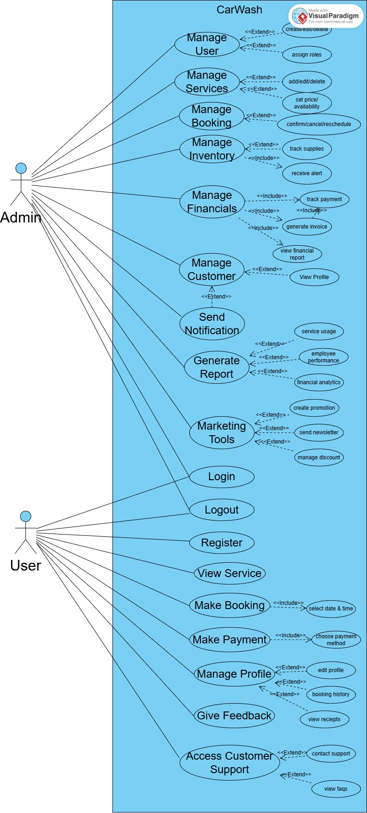
Figure 1: Use Case Diagram

1.6.2 Usage Scenario
Heading | Description
Use Case Title: | Manage User
Use Case ID: | UC-01
Actors: | Admin
Description: | Admin can create, edit, or delete user accounts and assign roles and permissions.
Pre-Condition: | Admin must be logged in.
Task Sequences: | 1. Go to User Management section  2. Select Create, Edit, or Delete User  3. Fill user details or make changes  4. Assign roles and permissions  5. Save changes
Alternative: | - Admin skips assigning roles  - Admin views user list only
Exception: | - User data missing  - System error while saving
Post Condition: | User account is created/updated/deleted successfully
Author: | BC210406443

Heading | Description
Use Case Title: | Manage Services
Use Case ID: | UC-02
Actors: | Admin
Description: | Admin can add, edit, or delete car wash services and set pricing and availability.
Pre-Condition: | Admin must be logged in.
Task Sequences: | 1. Go to Service Management section  2. Choose Add, Edit, or Delete Service  3. Enter or update service name, price, duration  4. Set availability  5. Save changes
Alternative: | - Admin updates only pricing  - Admin disables service temporarily
Exception: | - Missing service details  - Save operation fails
Post Condition: | Service is added, updated, or deleted successfully
Author: | BC210406443

Heading | Description
Use Case Title: | Manage Booking
Use Case ID: | UC-03
Actors: | Admin
Description: | Admin can view, confirm, reschedule, or cancel customer bookings.
Pre-Condition: | Admin must be logged in.
Task Sequences: | 1. Go to Booking Management section  2. View list of customer bookings  3. Select a booking  4. Confirm, reschedule, or cancel booking  5. Notify customer if needed
Alternative: | - Admin marks booking as completed  - Admin filters bookings by date
Exception: | - Booking not found  - Error in updating booking status
Post Condition: | Booking is managed and updated as required
Author: | BC210406443

Heading | Description
Use Case Title: | Manage Inventory
Use Case ID: | UC-04
Actors: | Admin
Description: | Admin can track inventory items, set reorder levels, and get alerts for low stock.
Pre-Condition: | Admin must be logged in.
Task Sequences: | 1. Go to Inventory section  2. View current inventory items  3. Add or update item quantity  4. Set reorder level for each item  5. Save changes and monitor alerts
Alternative: | - Admin disables an item temporarily  - Admin exports inventory list
Exception: | - Invalid item data  - Inventory update fails
Post Condition: | Inventory is updated and monitored for low stock alerts
Author: | BC210406443

Heading | Description
Use Case Title: | Manage Financials
Use Case ID: | UC-05
Actors: | Admin
Description: | Admin can generate invoices, track payments, view balances, and financial reports.
Pre-Condition: | Admin must be logged in.
Task Sequences: | 1. Go to Financial Management section  2. Generate customer invoices  3. Track paid and unpaid payments  4. View sales and revenue reports  5. Analyze financial data
Alternative: | - Admin filters reports by date  - Admin exports reports to PDF
Exception: | - Invoice generation fails  - Report data not loading
Post Condition: | Financial data is updated, invoices are generated, and reports are available
Author: | BC210406443

Heading | Description
Use Case Title: | Manage Customer
Use Case ID: | UC-06
Actors: | Admin
Description: | Admin can access and manage customer profiles, booking history, and send updates.
Pre-Condition: | Admin must be logged in.
Task Sequences: | 1. Go to Customer Management section  2. View list of registered customers  3. Access individual customer profile  4. View or update customer details and booking history  5. Send notifications or promotional updates
Alternative: | - Admin searches for customer by name or email  - Admin exports customer data
Exception: | - Customer not found  - Error updating profile
Post Condition: | Customer information is accessed/updated and notifications sent
Author: | BC210406443

Heading | Description
Use Case Title: | Send Notification
Use Case ID: | UC-07
Actors: | Admin
Description: | Admin can send reminders, promotional messages, or updates to customers.
Pre-Condition: | Admin must be logged in.
Task Sequences: | 1. Go to Notification section  2. Select customer(s) or group  3. Choose notification type (reminder, offer, etc.)  4. Write and send message
Alternative: | - Admin schedules a notification  - Admin sends a bulk message
Exception: | - Message not delivered  - Invalid recipient details
Post Condition: | Customers receive the intended notifications
Author: | BC210406443

Heading | Description
Use Case Title: | Generate Report
Use Case ID: | UC-08
Actors: | Admin
Description: | Admin can create reports on services, employee performance, and financial data.
Pre-Condition: | Admin must be logged in.
Task Sequences: | 1. Go to Reporting section  2. Select report type (service, employee, finance)  3. Choose report parameters (date, category)  4. Generate report  5. View or export report
Alternative: | - Admin customizes report layout  - Admin schedules automatic reports
Exception: | - Report generation error  - Data not available
Post Condition: | Report is generated and ready for analysis or export
Author: | BC210406443

Heading | Description
Use Case Title: | Marketing Tools
Use Case ID: | UC-09
Actors: | Admin
Description: | Admin can create and manage promotional campaigns, discounts, and newsletters.
Pre-Condition: | Admin must be logged in.
Task Sequences: | 1. Go to Marketing section  2. Create or edit campaigns and discounts  3. Schedule or send newsletters  4. Monitor campaign results
Alternative: | - Admin targets specific customer groups  - Admin pauses or stops campaigns
Exception: | - Campaign save fails  - Newsletter sending error
Post Condition: | Campaigns and newsletters are managed and tracked
Author: | BC210406443

Heading | Description
Use Case Title: | Login
Use Case ID: | UC-10
Actors: | Customer, Admin
Description: | Users enter their email and password to access the system.
Pre-Condition: | User must have an existing account.
Task Sequences: | 1. Go to login page  2. Enter email and password  3. Click login button  4. System verifies credentials  5. Grant access if valid
Alternative: | - User resets password if forgotten  - User chooses “Remember Me” option
Exception: | - Invalid email or password  - Account locked or inactive
Post Condition: | User is logged in and directed to their dashboard
Author: | BC210406443

Heading | Description
Use Case Title: | Logout
Use Case ID: | UC-11
Actors: | Customer, Admin
Description: | Users log out to securely end their session.
Pre-Condition: | User must be logged in.
Task Sequences: | 1. Click logout button  2. System ends user session  3. Redirect to login or homepage
Alternative: | - User closes browser without logging out
Exception: | - Session timeout occurs
Post Condition: | User is logged out and session is terminated
Author: | BC210406443

Heading | Description
Use Case Title: | Register
Use Case ID: | UC-12
Actors: | Customer
Description: | New users create an account by providing their details.
Pre-Condition: | User is not already registered.
Task Sequences: | 1. Go to registration page  2. Enter required information (name, email, password, etc.)  3. Submit registration form  4. System validates data  5. Account created and confirmation sent
Alternative: | - User registers using social media login  - User receives email verification link
Exception: | - Email already exists  - Invalid or missing required information
Post Condition: | User account is created and ready for login
Author: | BC210406443

Heading | Description
Use Case Title: | View Service
Use Case ID: | UC-13
Actors: | Customer
Description: | Customers can browse and view details of available car wash services and packages.
Pre-Condition: | Customer must be logged in or browsing as guest.
Task Sequences: | 1. Navigate to Services page  2. Browse list of available services  3. Select a service to see details  4. View pricing, duration, and description
Alternative: | - Customer filters services by type or price  - Customer searches for a specific service
Exception: | - Service details fail to load  - No services available
Post Condition: | Customer views service information
Author: | BC210406443

Heading | Description
Use Case Title: | Make Booking
Use Case ID: | UC-14
Actors: | Customer
Description: | Customer selects service, chooses date and time, and confirms a booking.
Pre-Condition: | Customer must be logged in.
Task Sequences: | 1. Go to Booking page  2. Select desired service(s)  3. Choose date and time  4. Confirm booking details  5. Submit booking request  6. Receive booking confirmation
Alternative: | - Customer modifies booking before confirmation  - Customer cancels booking before submission
Exception: | - Selected slot unavailable  - Booking submission fails
Post Condition: | Booking is saved and confirmation sent to customer
Author: | BC210406443

Heading | Description
Use Case Title: | Make Payment
Use Case ID: | UC-15
Actors: | Customer
Description: | Customer pays for the booked car wash service using available payment methods.
Pre-Condition: | Customer must have a confirmed booking.
Task Sequences: | 1. Go to Payment page  2. Select payment method (credit card, PayPal, etc.)  3. Enter payment details  4. Submit payment 5. Receive payment confirmation
Alternative: | - Customer saves payment info for future use  - Customer cancels payment
Exception: | - Payment declined  - Payment gateway error
Post Condition: | Payment is processed and recorded
Author: | BC210406443

Heading | Description
Use Case Title: | Manage Profile
Use Case ID: | UC-16
Actors: | Customer
Description: | Customer views and updates their personal information and contact details.
Pre-Condition: | Customer must be logged in.
Task Sequences: | 1. Go to Profile page  2. View current personal information  3. Edit details as needed  4. Save changes  5. Receive confirmation of update
Alternative: | - Customer changes password  - Customer uploads profile picture
Exception: | - Invalid input data  - Save operation fails
Post Condition: | Profile information is updated successfully
Author: | BC210406443

Heading | Description
Use Case Title: | Give Feedback
Use Case ID: | UC-17
Actors: | Customer
Description: | Customer submits feedback and ratings about the car wash services received.
Pre-Condition: | Customer must be logged in and have completed a service.
Task Sequences: | 1. Go to Feedback page  2. Select service to review  3. Enter rating and comments  4. Submit feedback  5. Receive acknowledgment
Alternative: | - Customer edits feedback before submitting  - Customer chooses to submit anonymous feedback
Exception: | - Feedback submission fails  - Invalid or incomplete feedback
Post Condition: | Feedback is saved and available for admin review
Author: | BC210406443

Heading | Description
Use Case Title: | Access Customer Support
Use Case ID: | UC-18
Actors: | Customer
Description: | Customer contacts support via chat, email, or phone for help or questions.
Pre-Condition: | Customer must be logged in.
Task Sequences: | 1. Go to Support/Help page  2. Choose support method (chat, email, phone)  3. Enter message or query  4. Submit request  5. Wait for support response
Alternative: | - Customer views FAQ before contacting support  - Customer uses chatbot
Exception: | - No response from support team  - Chat not available
Post Condition: | Customer query is submitted and response is received or queued
Author: | BC210406443

1.7 DEVELOPMENT METHODOLOGY

1.7.1 VU Methodology
Waterfall Model

The first published model of the software development process was derived from other engineering processes. Because of the cascade from one phase to another, this model is known as the waterfall model. This model is also known as linear sequential model. This model is depicted in the following diagram.

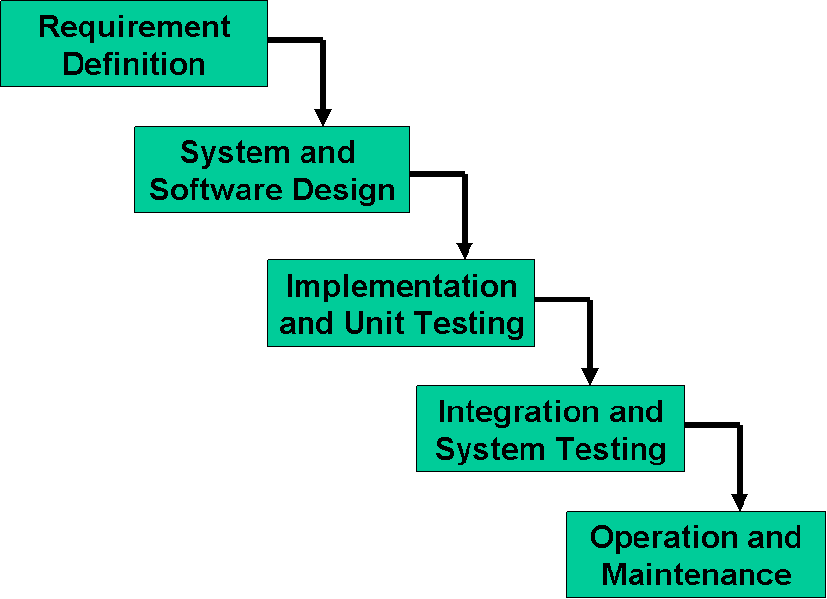

The principal stages of the model map directly onto fundamental development activities.

It suggests a systematic, sequential approach to software development that begins at the system level and progresses through the analysis, design, coding, testing, and maintenance.

In the literature, people have identified from 5 to 8 stages of software development.

The five stages above are as follows:
- Requirement Analysis and Definition: What - The systems services, constraints and goals are established by consultation with system users. They are then defined in detail and serve as a system specification.
- System and Software Design: How – The system design process partitions the requirements to either hardware of software systems. It establishes and overall system architecture. Software design involves fundamental system abstractions and their relationships.
- Implementation and Unit Testing: - How – During this stage the software design is realized as a set of programs or program units. Unit testing involves verifying that each unit meets its specifications.
- Integration and system testing: The individual program unit or programs are integrated and tested as a complete system to ensure that the software requirements have been met. After testing, the software system is delivered to the customer.
- Operation and Maintenance: Normally this is the longest phase of the software life cycle. The system is installed and put into practical use. Maintenance involves correcting errors which were not discovered in earlier stages of the life-cycle, improving the implementation of system units and enhancing the system’s services as new requirements are discovered.

In principle, the result of each phase is one or more documents which are approved. No phase is complete until the documentation for that phase has been completed and products of that phase have been approved. The following phase should not start until the previous phase has finished.

Real projects rarely follow the sequential flow that the model proposes. In general these phases overlap and feed information to each other. Hence there should be an element of iteration and feedback. A mistake caught any stage should be referred back to the source and all the subsequent stages need to be revisited and corresponding documents should be updated accordingly. This feedback path is shown in the following diagram.

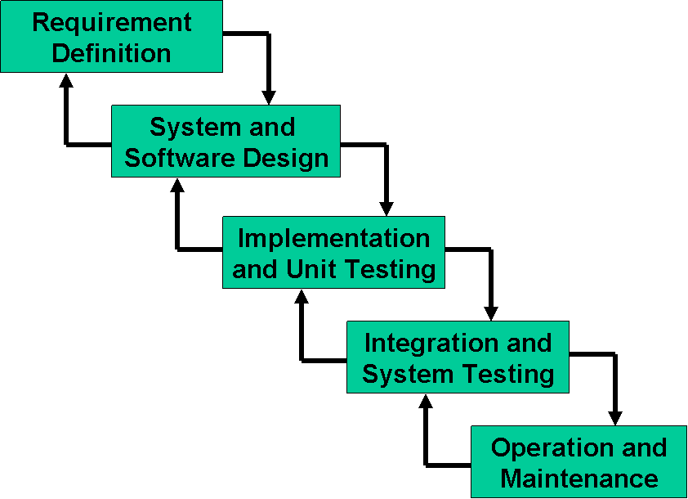

Because of the costs of producing and approving documents, iterations are costly and require significant rework.

The Waterfall Model is a documentation-driven model. It therefore generates complete and comprehensive documentation and hence makes the maintenance task much easier. It however suffers from the fact that the client feedback is received when the product is finally delivered and hence any errors in the requirement specification are not discovered until the product is sent to the client after completion. This therefore has major time and cost related consequences.

Spiral Model
This model was developed by Barry Boehm. The main idea of this model is to avert risk as there is always an element of risk in development of software. For example, key personnel may resign at a critical juncture, the manufacturer of the software development may go bankrupt, etc.

In its simplified form, the Spiral Model is Waterfall model plus risk analysis. In this case each stage is preceded by identification of alternatives and risk analysis and is then followed by evaluation and planning for the next phase. If risks cannot be resolved,
Risk Analysis
Verify
Rapid Prototype
Specification
Design
Implementation
project is immediately terminated. This is depicted in the following diagram.

As can be seen, a Spiral Model has two dimensions. Radial dimension represents the cumulative cost to date and the angular dimension represents the progress through the spiral. Each phase begins by determining objectives of that phase and at each phase a new process model may be followed.

A full version of the Spiral Model is shown below:

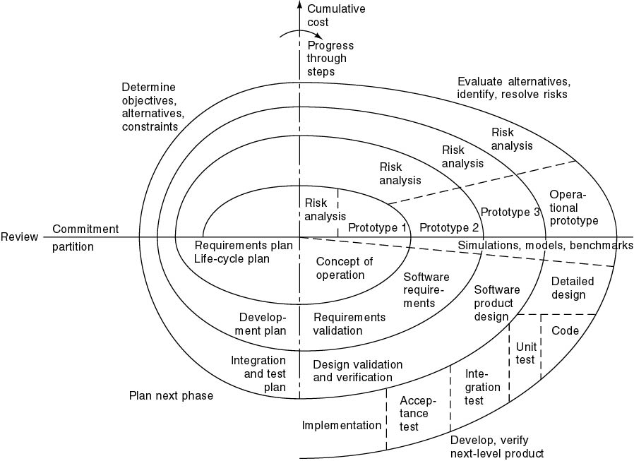

The main strength of the Spiral Model comes from the fact that it is very sensitive to the risk. Because of the spiral nature of development, it is easy to judge how much to test and there is no distinction between development and maintenance. It however can only be used for large-scale software development and that too for internal (in-house) software only.
Plan Next Phase
Determine objectives, alternatives, constraints
Identify and resolve risks
Develop and verify next-level product
Adopted Methodology
The adopted methodology for this project is VU Process Model which is a combination of waterfall and spiral models. VU Process Model is the combination of waterfall methodology and spiral methodology. It is also called hybrid approach of system development. It has five phases.
The five phases of the VU process model are following:
- Gathering and Analyzing requirement
- Planning
- Analysis and Design
- Development
- Final Report
In the requirement phase, the system goals, services and constrains are established after discussion with user. The planning phase is synchronized effort to find all the potential to tackle each. This phase usually involves a lot of brainstorming within software development team as well as with respective client. It maximizes the quality of system and minimizes any risks and errors.
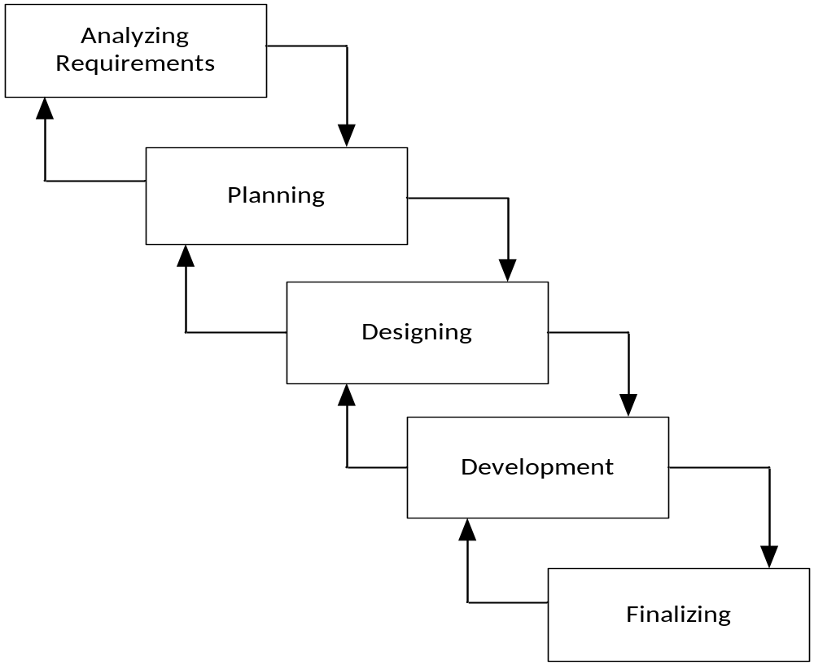

1.7.2 Reason for Choosing VU Methodology
As we know that ever model have advantages and also disadvantages in accordance with the project requirements. We should choose the right type of the Model to implement based on the scope of the software project. This depends on a number of factors, some of which are the scope of the project, project budget, environment, available resources. But after studying the requirements of the project we choose VU process model which is a combination of waterfall and spiral models.
Following are the reasons for choosing this Methodology:
- The Spiral Model or the Spiral Development Model combines the best of the both top down and bottom up approaches and is specifically risk-driven. In essence the Spiral Model is a combination of the classic Waterfall Model and Risk Analysis.

- The Spiral Model provides a rapid development and at the same time, incremental versions of the software application.
- The combination of Waterfall and Spiral Model provides an orderly sequence of development steps and helps ensure the adequacy of documentation and design reviews to ensure the quality, reliability and maintainability of the developed software.
- Combination of Waterfall and Spiral models allows for feedback and creativity.
- In Spiral model, the project life cycle is divided into phases, and each phase is executed in all of the iteration of the Spiral Model.
- Unlike the waterfall model, where milestones are reached in a very linear manner, and you are not allowed to backtrack, the VU process model uses the spiral model’s ability to perform iterations when needed.

1.7.3 Working Plan
Work plan is a document that shows all task involved in a project. The Work plan is backbone of any Project if our plane is suitable for project then project will be completed within time and budget. Project plane shows the tasks and responsibilities distribution. We plan the software development Progress mainly. It describes the team management, standards, processes and constraints of project resources. Plan consists of following stages.
- Team Structure
- Detailed Project Schedule

1.7.4 Project Schedule
The task assign in the above plane are the base of all work plan the day wise allocation to each phase is represented bellow.

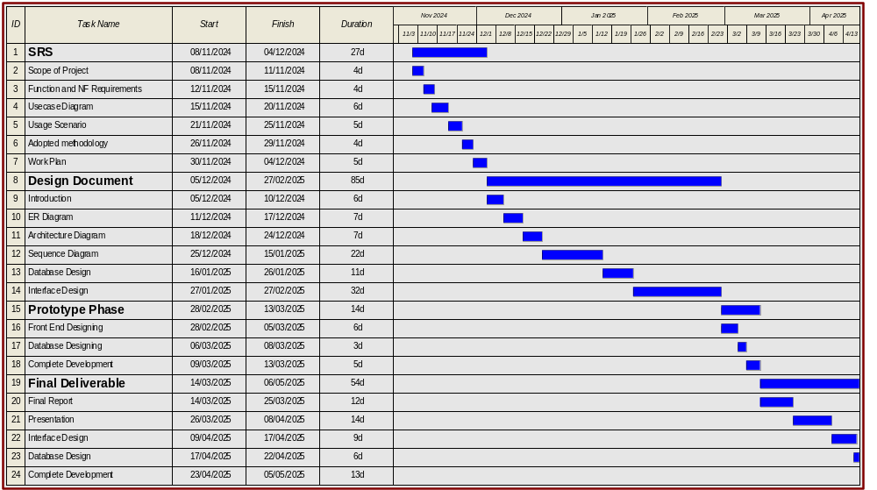

CHAPTER 2
Designing the Project

2.1 INTRODUCTION
The main propose of Design phase is to change from “What to do” to “How to do”. The phase tells that how this project works in details. Design phase summarized the project. This phase based on different representation diagrams like class diagram, sequence diagram database diagram etc.…
During the detailed analysis and design phase, the project manager and the system development manager work closely together to.
This phase has some major feature as below: -
- This phase includes the processes represented by graphical diagrams available in software engineering.
- Major component selection has been made.
- Define functional and system requirements that are not easily expressed in data and process models.
- Develop detailed data and process models
- Define the high level architecture and logical design to support the system, functional, and electronic records management requirements,
- Continue to identify and mitigate risk that the technology can be phased-in and coordinated with the users.

2.2 PURPOSE
The purpose of designing the project is present the project logically. Define the functional system requirements. It defines how the system is actually work and how system is look like. It also summarizes the project.

2.3 SCOPE
The scope of this design document is to outline the detailed structure and visual layout of the project. It includes all aspects of the user interface design, covering the arrangement of elements, colour schemes, typography, and interactive features. This document will guide the development team in implementing the front-end of the project, ensuring that all design components align with the project's overall goals. It also serves as a reference for future updates, helping maintain consistency in the visual presentation across different sections and pages.

Additionally, the design document defines the technical specifications, including the use of HTML, CSS, and other tools or frameworks required to build the interface. It addresses the user experience (UX) principles by ensuring that the design is easy to navigate, visually appealing, and responsive across devices. By clearly defining the design guidelines and requirements, this document ensures that the final product will meet user expectations and deliver a seamless experience.

2.4 DEFINITIONS, ACRONYMS AND ABBREVIATION
ERD: Entity Relation Diagram
Sequence Diagram: Show the sequence of a function
Database Design: How data is save (Structural form)
Class Diagram: Show the static view of an application

2.5 ER DIAGRAM
The ER model defines the conceptual view of a database. It works around real-world entities and the associations among them. At view level, the ER model is considered a good option for designing databases.
Entity
An entity can be a real-world object, either animate or inanimate, that can be easily identifiable. For example, in a school database, students, teachers, classes, and courses offered can be considered as entities. All these entities have some attributes or properties that give them their identity. An entity set is a collection of similar types of entities. An entity set may contain entities with attribute sharing similar values. For example, a Students set may contain all the students of a school; likewise, a Teachers set may contain all the teachers of a school from all faculties. Entity sets need not be disjoint.
Attributes
Entities are represented by means of their properties, called attributes. All attributes have values. For example, Customer entity may have name, ID, and email as attributes. There exists a domain or range of values that can be assigned to attributes. For example, Customer’s name cannot be a numeric value. It has to be alphabetic. A Customer’s email must be proper format, etc.
Relationship
The association among entities is called relationship. For example, a customer sends Booking and Electrician have Booking. Here, send and have are called relationships.
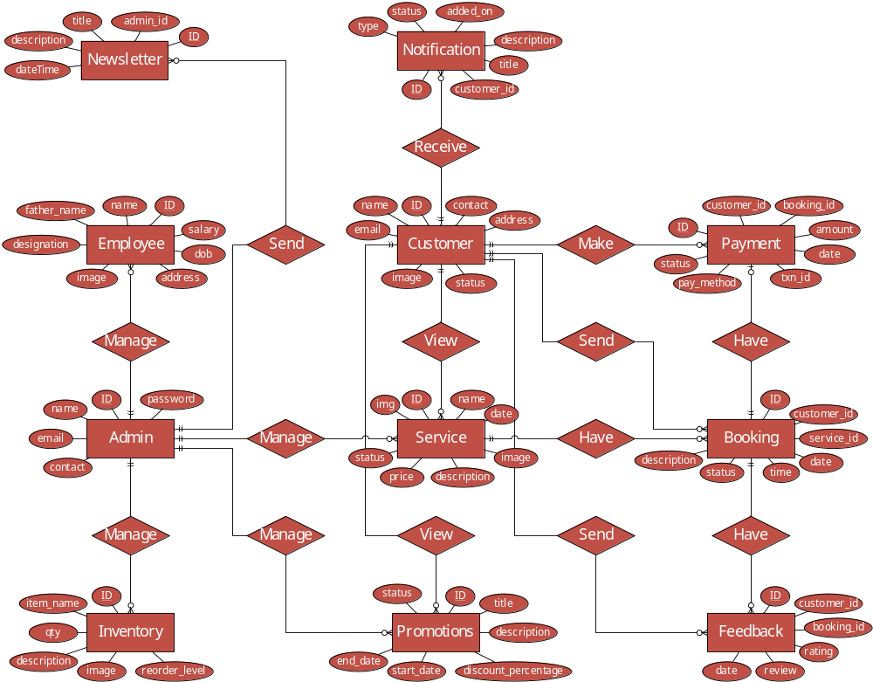
Figure 2: Entity Relationship Diagram

2.6 ARCHITECTURE DIAGRAM
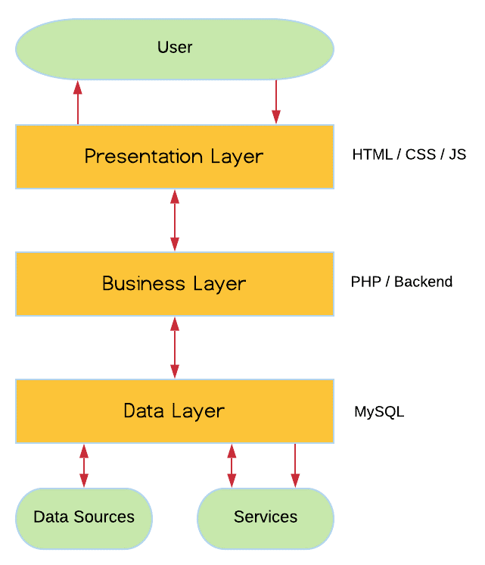

Figure 3: Architecture Diagram

2.7 DYNAMIC MODEL (SEQUENCE DIAGRAM)

2.7.1 Login
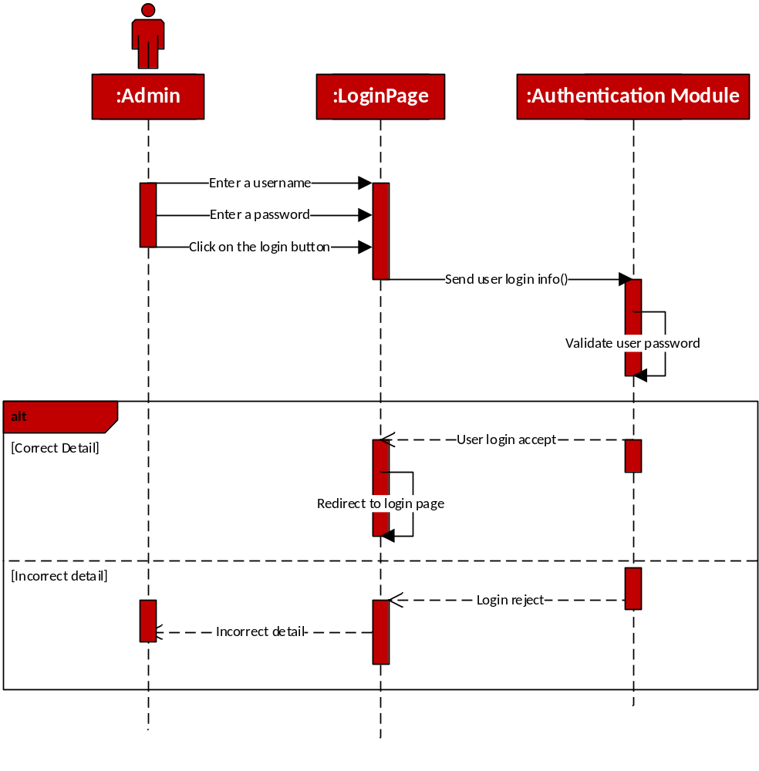
Figure 4: Login Sequence

2.7.2 Register
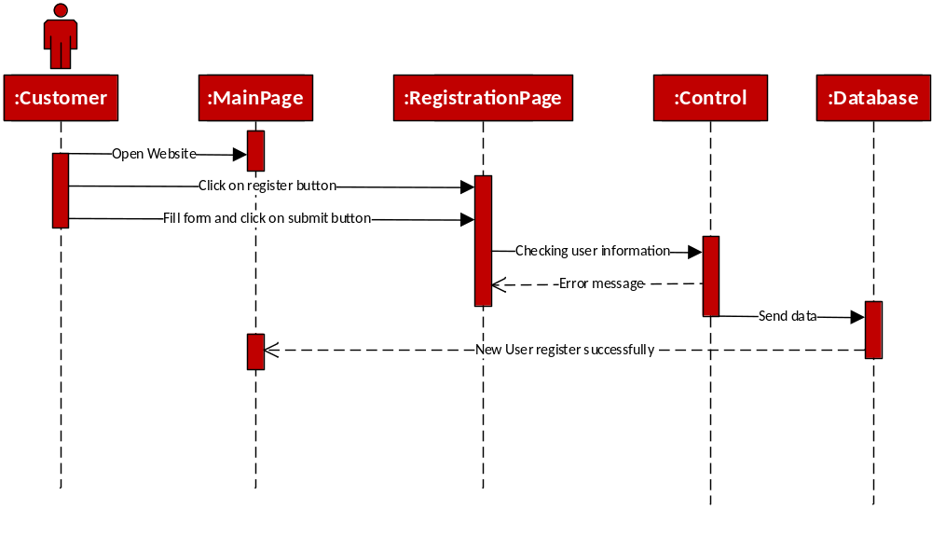
Figure 5: Register Sequence

2.7.3 Manage User
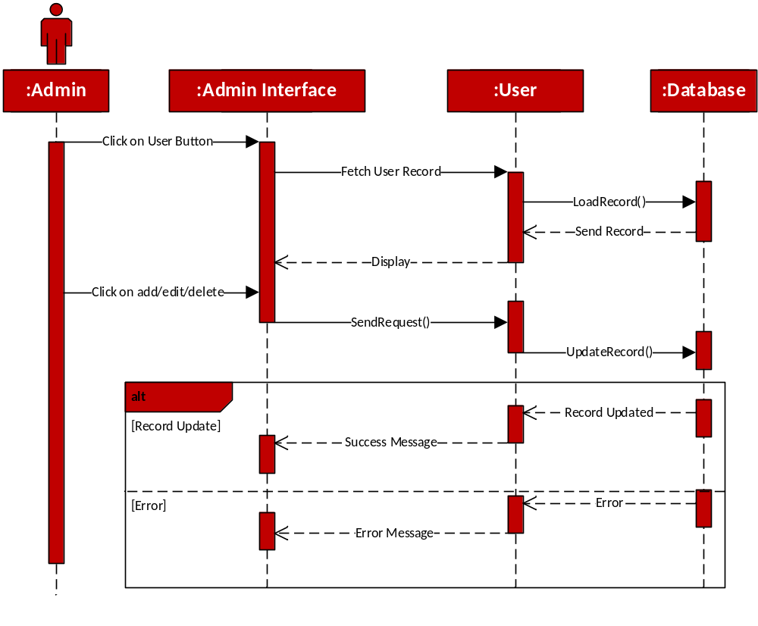
Figure 6: Manage User Sequence

2.7.4 Manage Services Sequence
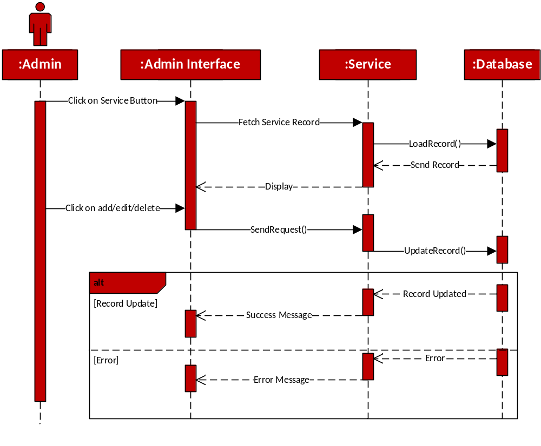
Figure 7: Manage Service

2.7.5 Manage Booking
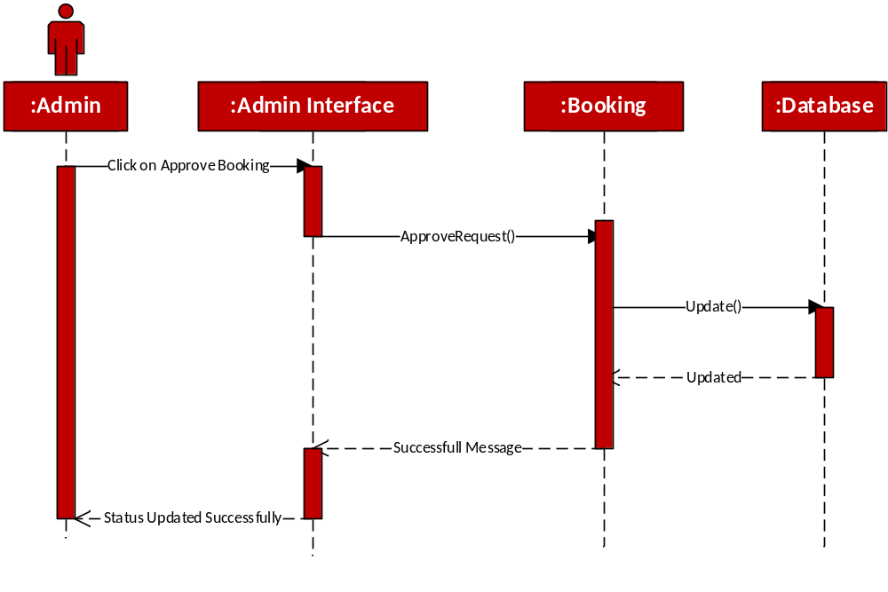
Figure 8: Manage Booking

2.7.6 Generate Report
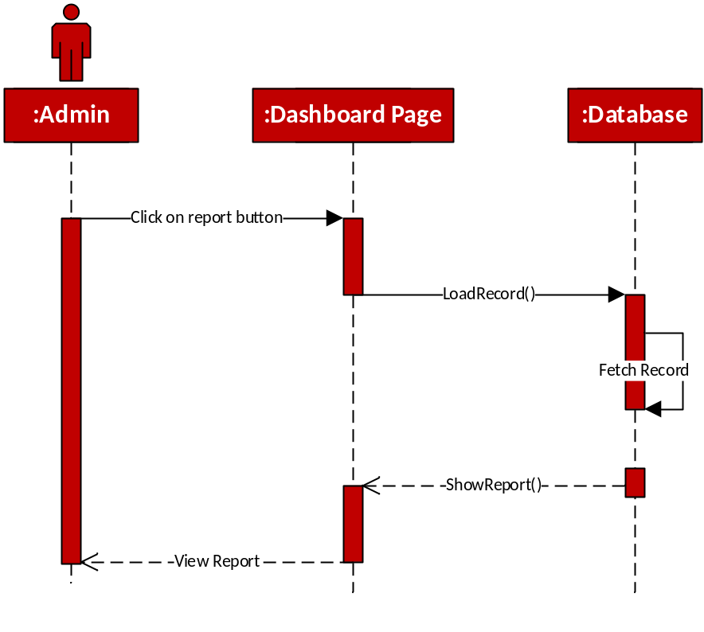
Figure 9: Generate Report

2.7.7 View Service
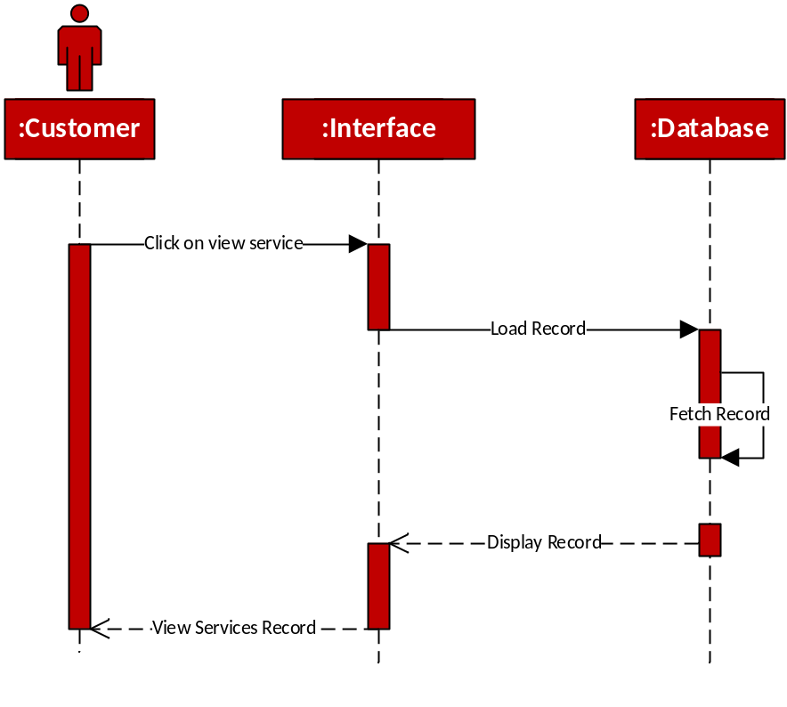
Figure 10: View Service

2.7.8 Send Booking
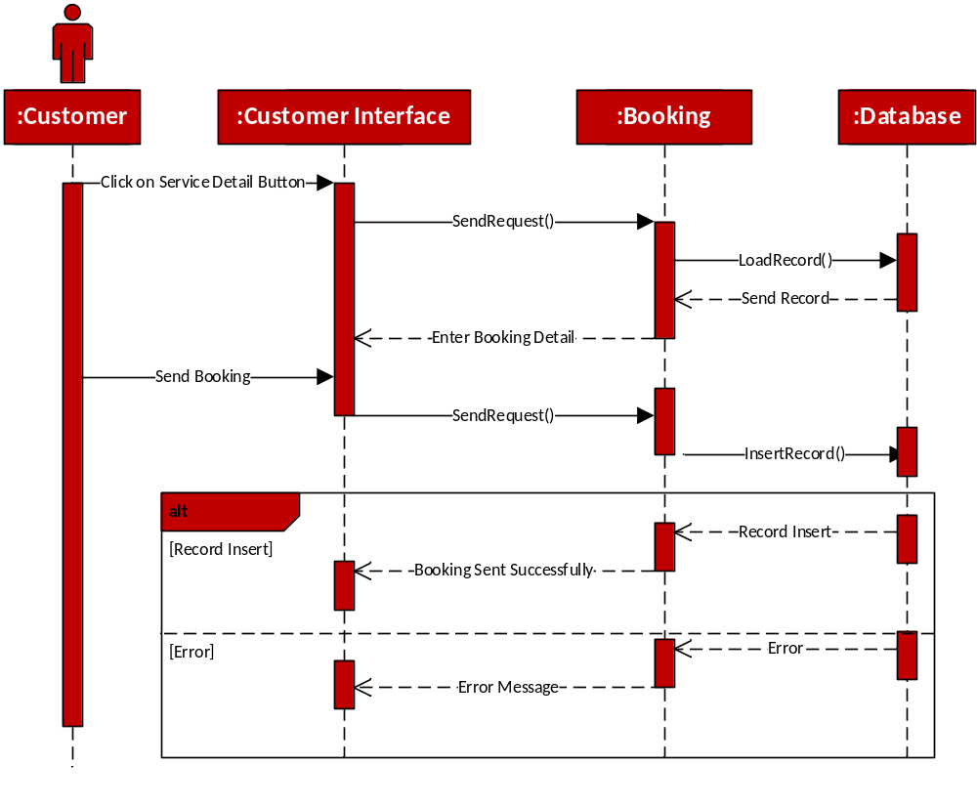
Figure 11: Send Booking Sequence

2.7.9 Manage Profile Sequence
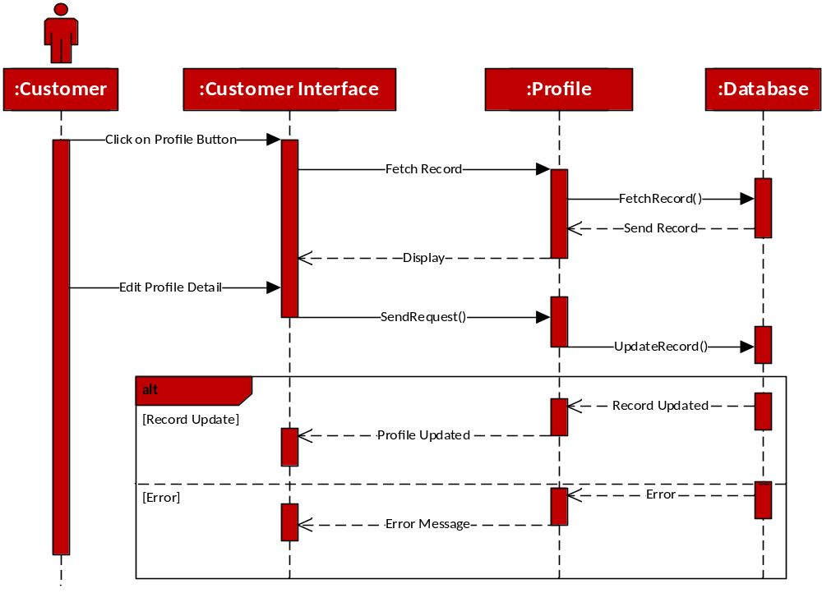
Figure 12: Place Order Sequence

2.7.10 Search Service
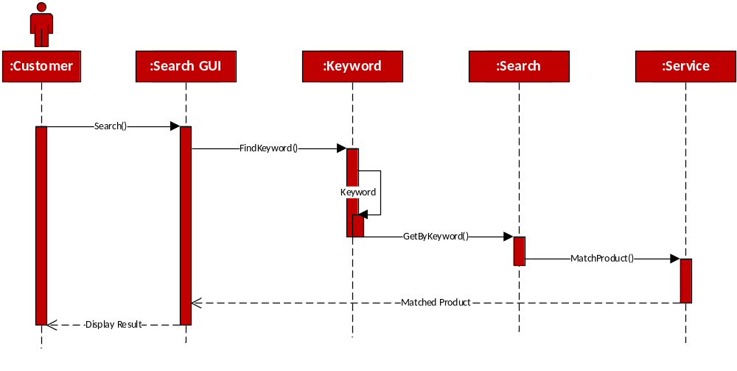
Figure 13: Search Service

2.7.11 View Notification
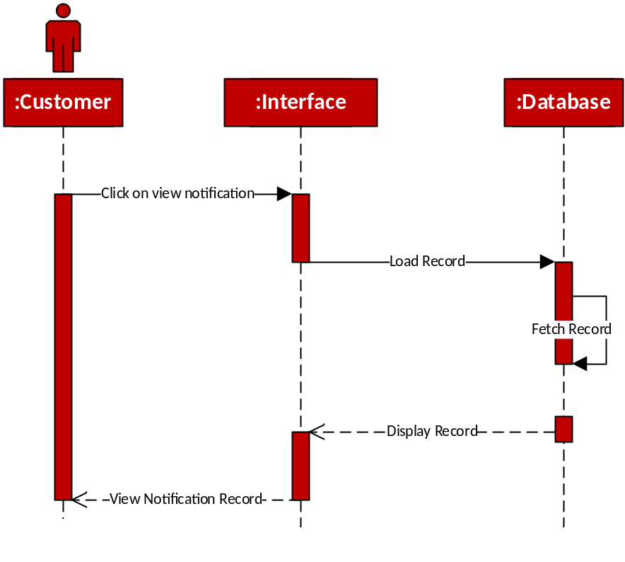
Figure 14: View Notification Sequence

2.7.12 Give Feedback
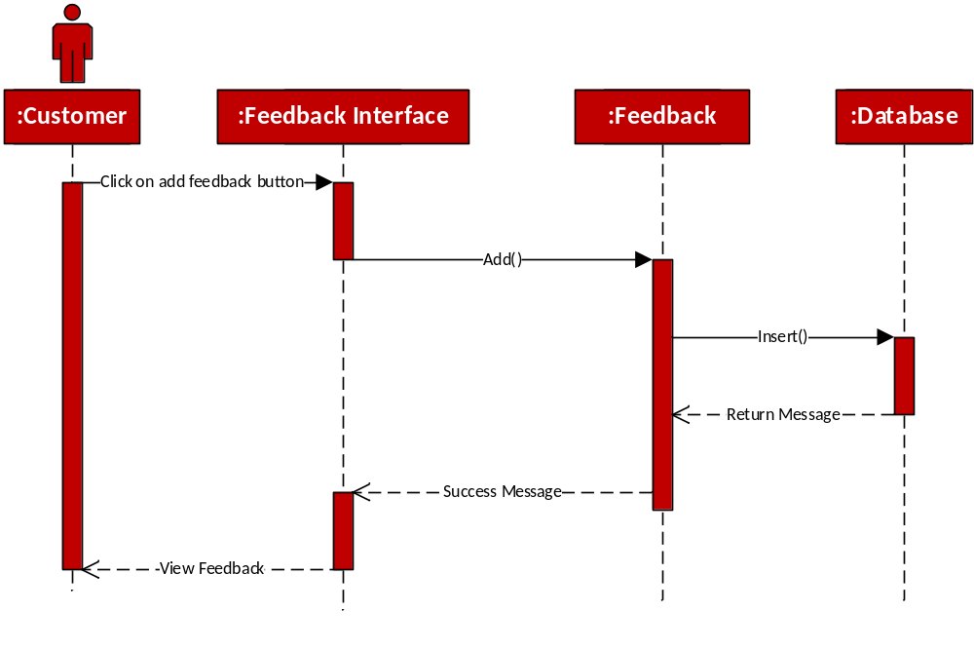
Figure 15: Give Feedback Sequence

2.7.13 Logout
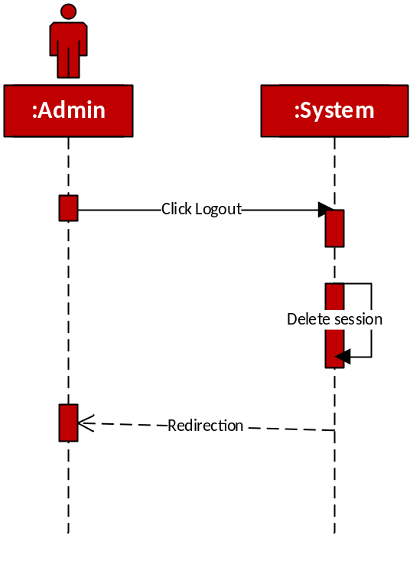
Figure 16: Logout Sequence

2.8 LOGICAL MODEL (CLASS DIAGRAM)
The class diagram is a static diagram. It represents the static view of an application. Class diagram is not only used for visualizing, describing and documenting different aspects of a system but also for constructing executable code of the software application. The class diagram describes the attributes and operations of a class and also the constraints imposed on the system. The class diagrams are widely used in the modelling of object-oriented systems because they are the only UML diagrams which can be mapped directly with object oriented languages. The class diagram shows a collection of classes, interfaces, associations, collaborations and constraints. It is also known as a structural diagram.
Purpose
The purpose of the class diagram is to model the static view of an application. The class diagrams are the only diagrams which can be directly mapped with object-oriented languages and thus widely used at the time of construction. The UML diagrams like activity diagram, sequence diagram can only give the sequence flow of the application but class diagram is a bit different. So, it is the most popular UML diagram in the coder community. So, the purpose of the class diagram can be summarized as:
- Analysis and design of the static view of an application.
- Describe responsibilities of a system.
- Base for component and deployment diagrams.
- Forward and reverse engineering.

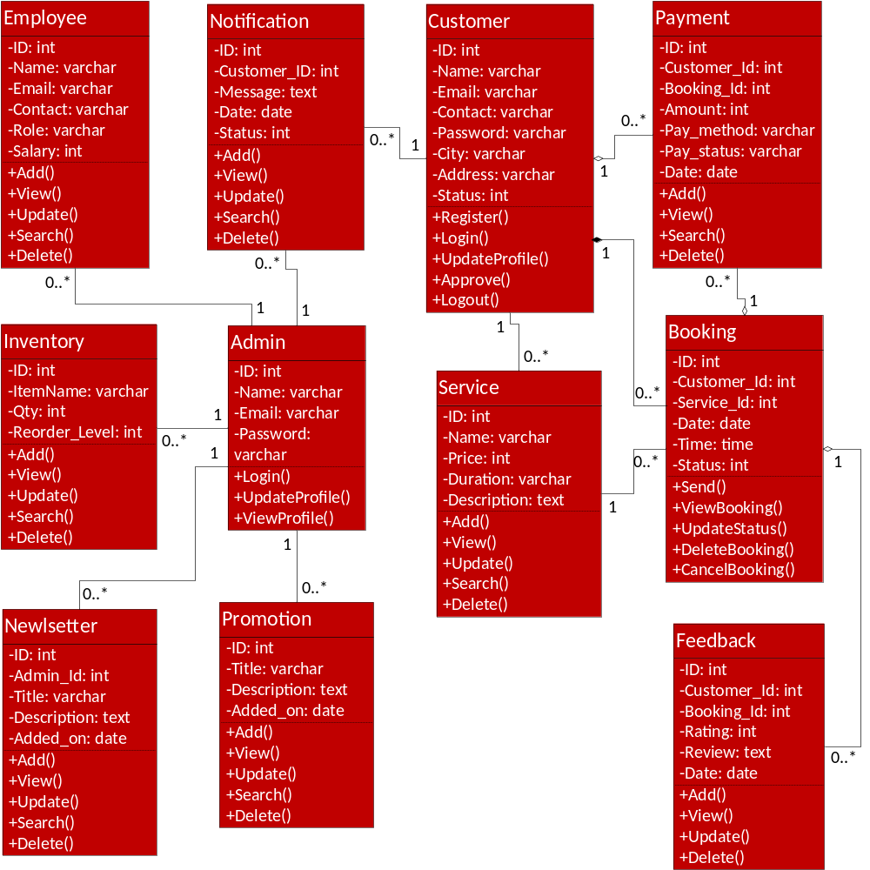
Figure 17: Class Diagram

2.9 DATABASE MODEL (DATABASE DIAGRAM)
The general theme behind a database is to handle information as an integrated whole. A database is a collection of interrelated data stored with minimum redundancy to serve many users quickly and effectively. After designing input and output, the analyst must concentrate on database design or how data should be organized around user requirements. The general objective is to make information access, easy quick, inexpensive and flexible for other users. During database design the following objectives are concerned:
- Controlled Redundancy
- Data independence
- Accurate and integrating
- More information at low cost
- Recovery from failure
- Privacy and security
- Performance
Tables
A table is a collection of data elements organized in terms of rows and columns. A table is also considered as convenient representation of relations.
Records
A single entry in a table is called a Record or Row. A Record in a table represents set of related data.
Fields
A table consists of several records (row) each record can be broken into several smaller entities known as Fields.
Columns
A column is a set of value of a particular type. The term Attribute is also used to represent a column.

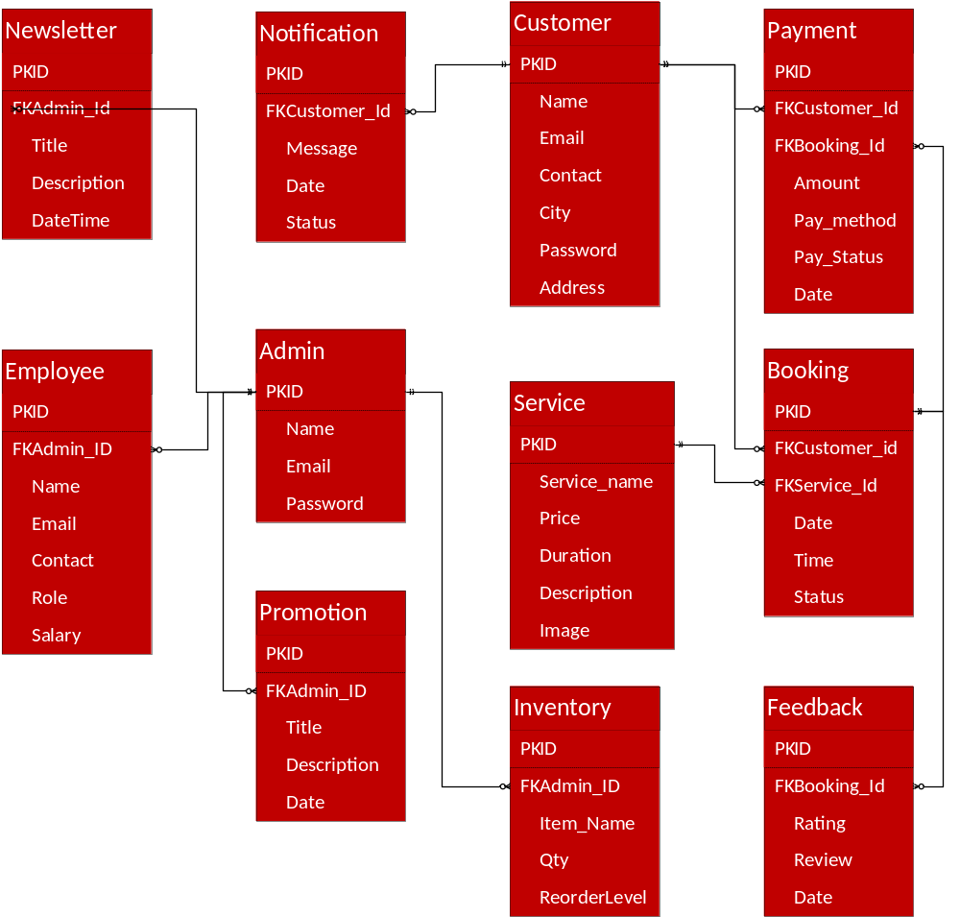
Figure 18: Database Diagram

2.10 GRAPHICAL USER INTEFACE
Home Page


View Service
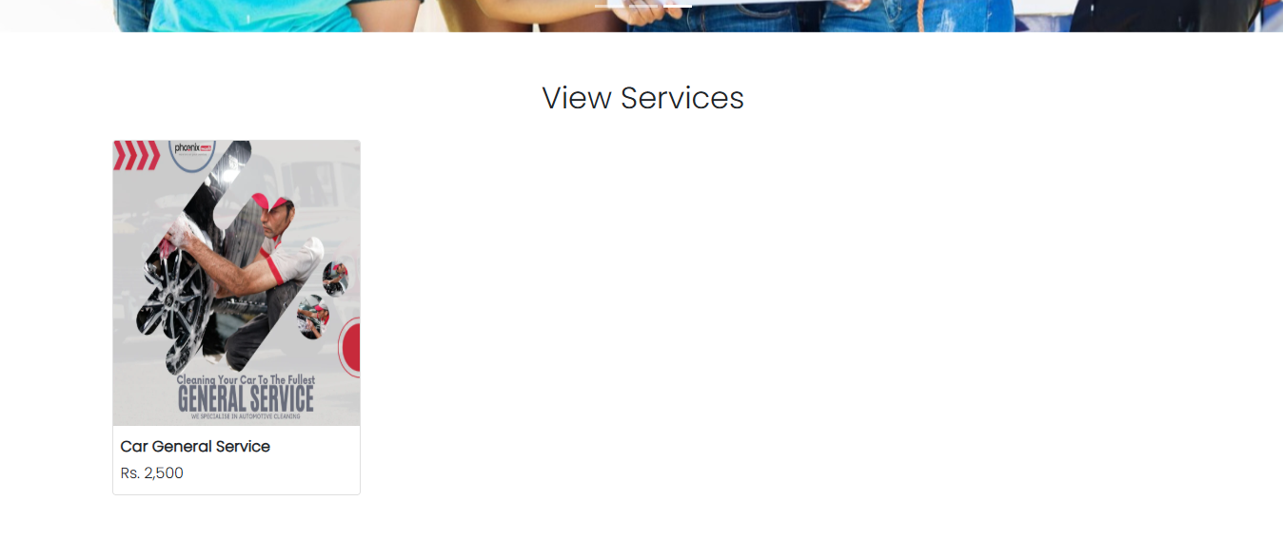
View Products
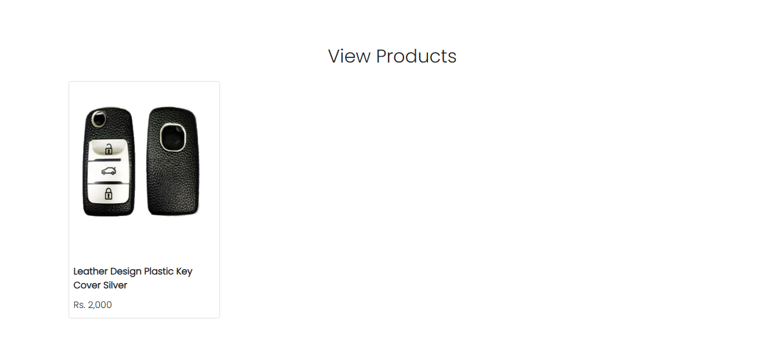

Service Detail
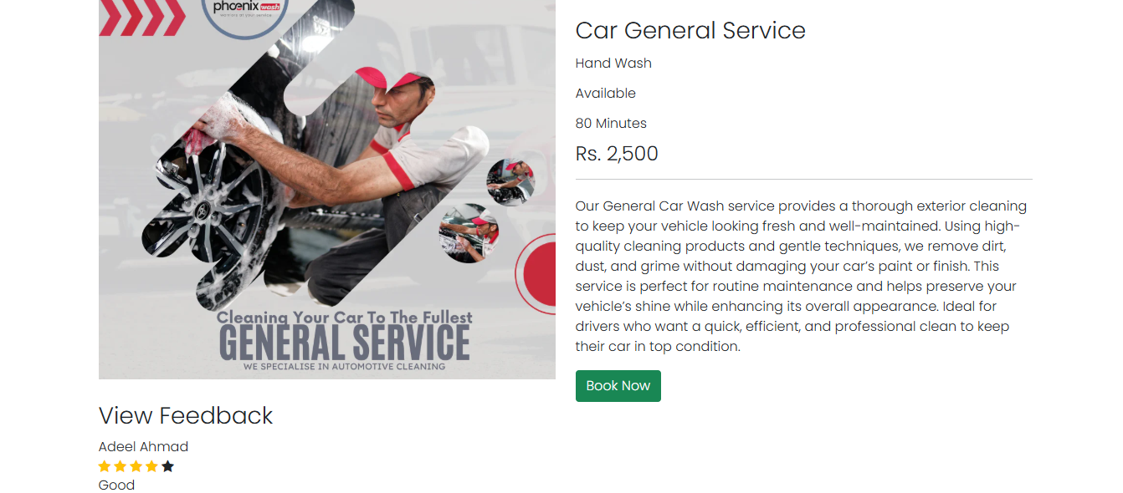
Send Booking
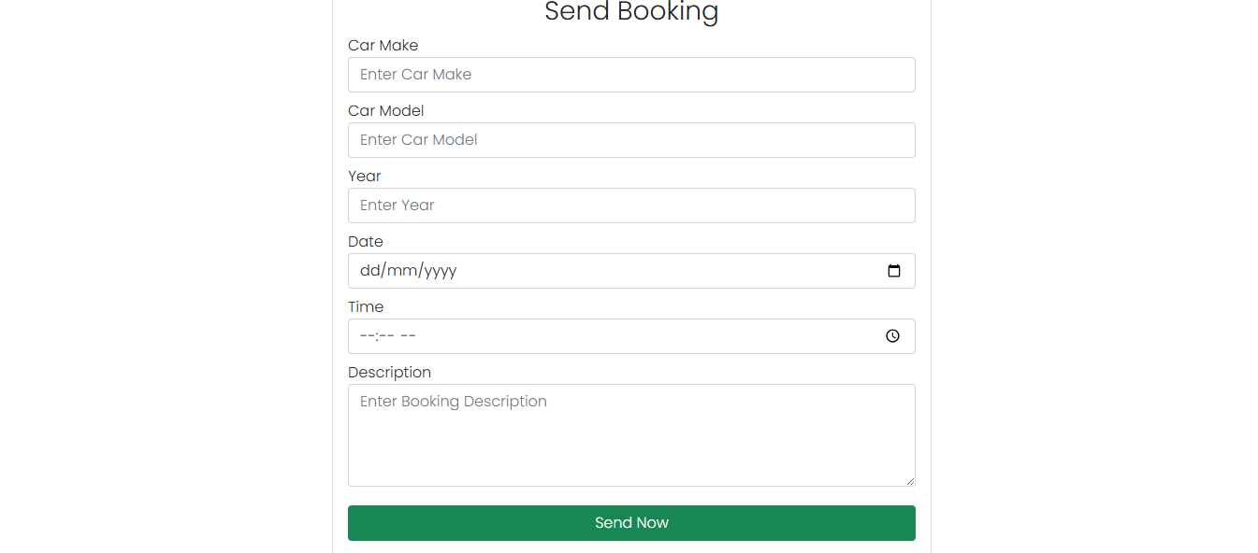

View Booking
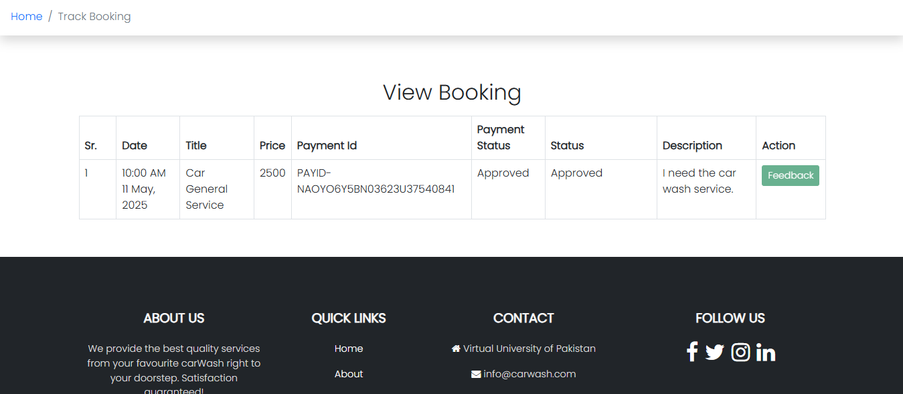

Admin Login
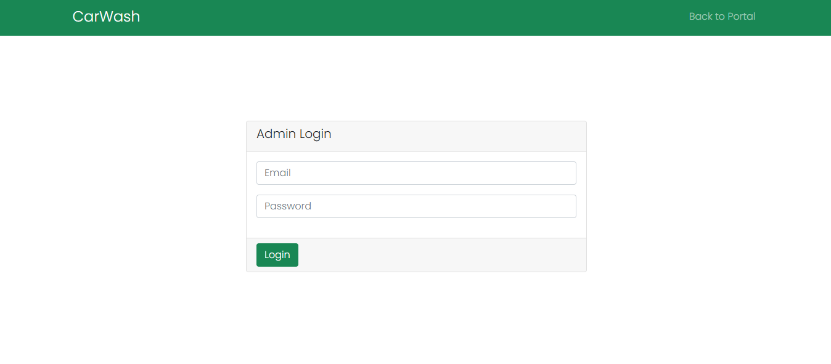

Admin Dashboard
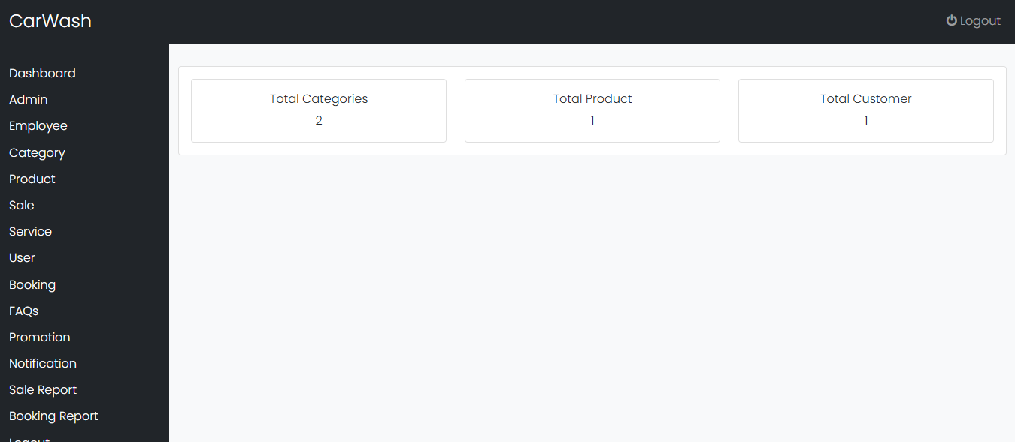

Manage Admin
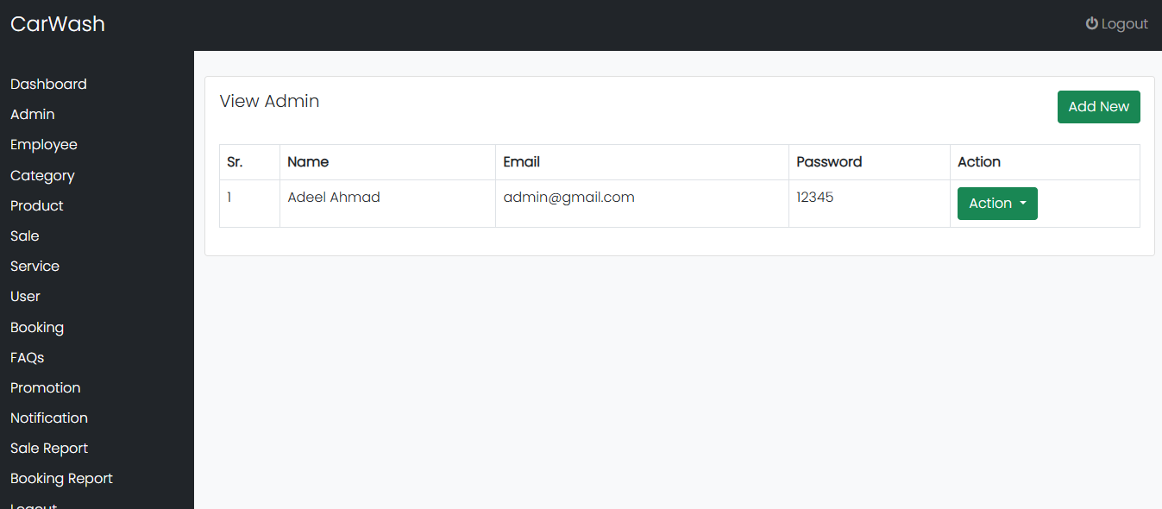

Manage Employee
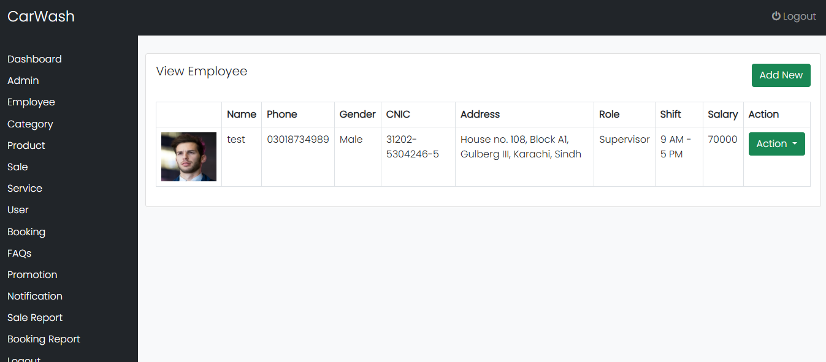

Manage Category
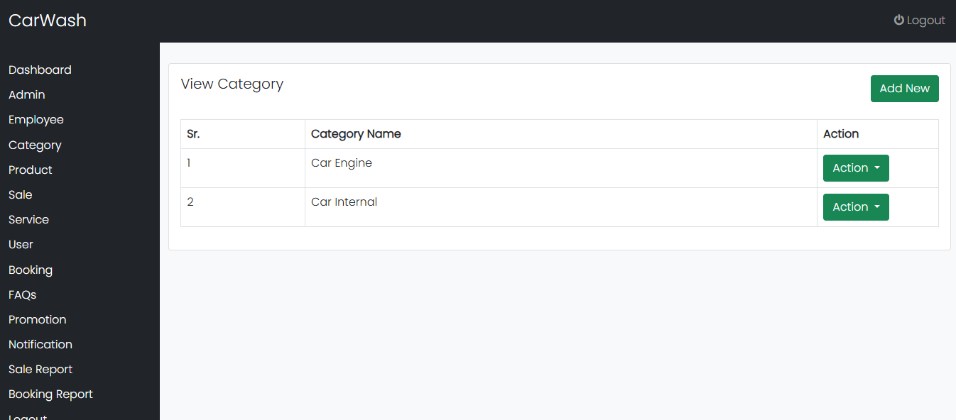

Manage Product
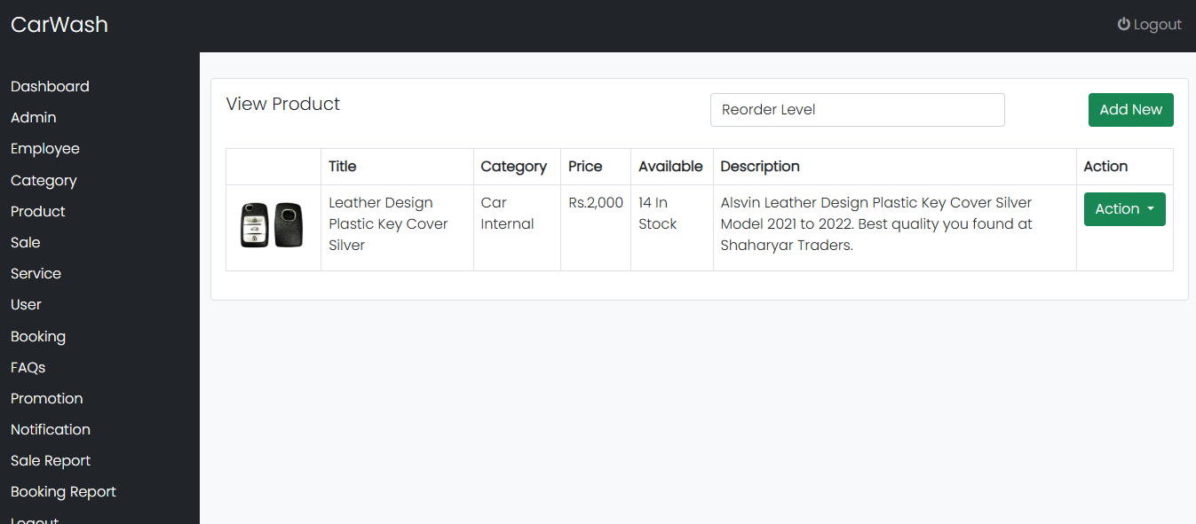

Manage Service
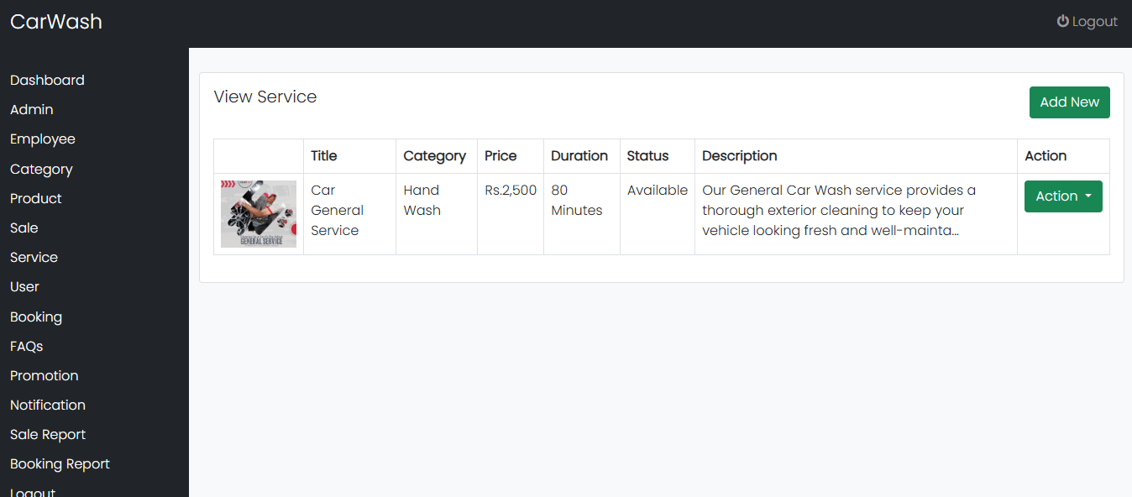

Manage Customer
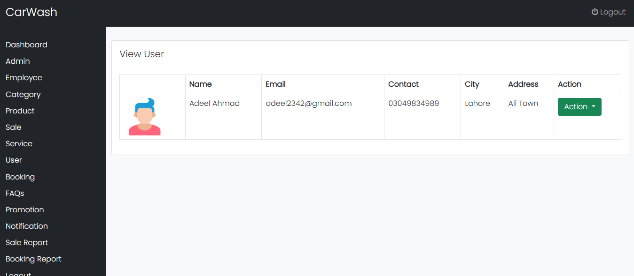

Manage Booking
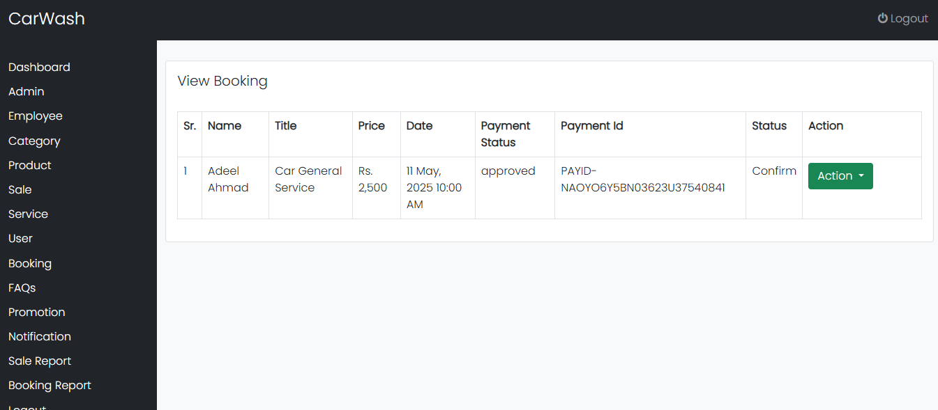

Generate Report
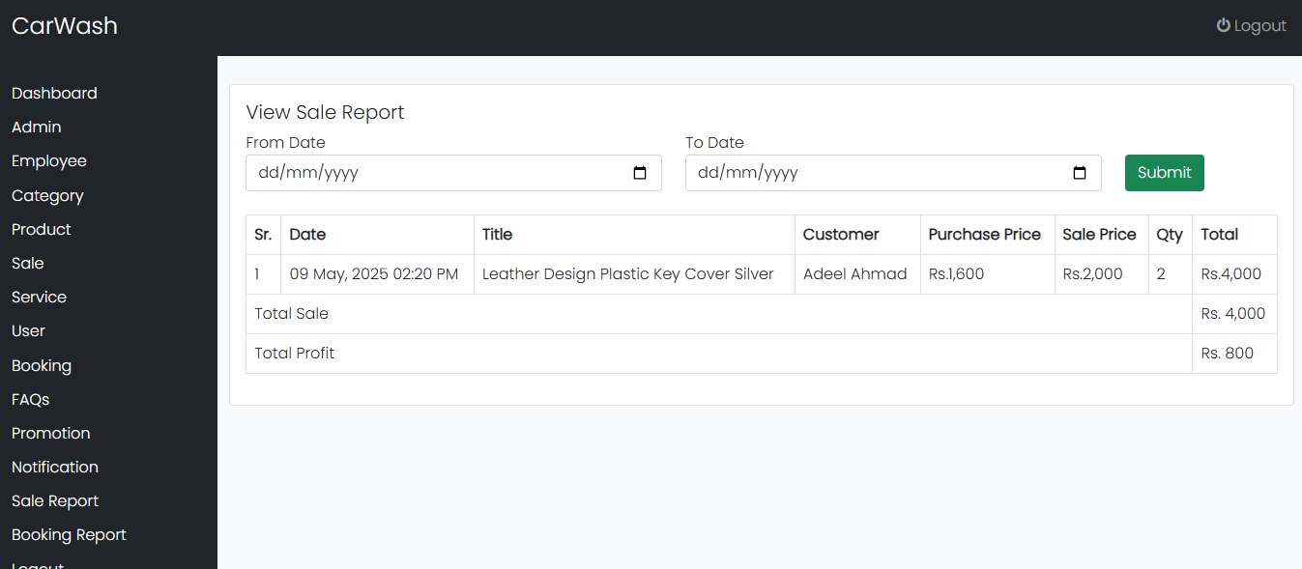

CHAPTER 3
Development

3.1 DEVELOPMENT PLAN (ARCHITECTURE DIAGRAM)

REFERENCES

[1.] www.edrawmax.com
[2]. www.lucidchart.com
[3]. www.w3school.com
[4]. www.guru99.com
[5]. www.xampp.com
[6]. www.php.com
[7]. www.ilmkidunya.com
[8]. www.slideshare.com
[9]. www.freeproject.com

APPENDIX

Section 1 | Gathering & Analyzing Info
Section 2 | Designing the Project
Section 3 | Development

